**Perfect competition and monopoly**

Problem Set

PART A:

1. Perfect competition is an industry with -

A) a few firms producing identical goods.

B) many firms producing goods that differ somewhat.

C) a few firms producing goods that differ somewhat in quality.

D) many firms producing identical goods. (answer)

2) In a perfectly competitive industry, there are -

A) many buyers and many sellers. (answer)

B) many sellers, but there might be only one or two buyers.

C) many buyers, but there might be only one or two sellers.

D) one firm that sets the price for the others to follow.

3) In perfect competition, restrictions on entry into an industry -

A) do not exist. (answer)

B) apply to labor but not to capital.

C) apply to both capital and labor.

D) apply to capital but not to labor.

4) In perfect competition, -

A) there are significant restrictions on entry.

B) Each firm can influence the price of the goods.

C) there are few buyers.

D) all firms in the market sell their product at the same price. (answer)

5) Economists assume that a perfectly competitive firm's objective is to maximize its -

A) revenue.

B) economic profit. (answer)

C) output price.

D) quantity sold

Part B

Q1. A perfectly competitive firm sells its products for $300. Complete the table below. Find the following: profit-maximizing price, profit-maximizing quantity, and greatest possible profit. Be sure to use the profit-maximization condition to find the profit-maximizing quantity.

| Q | P | TR | TC | Profit | MR | MC |
| --- | --- | --- | --- | --- | --- | --- |
| 0 |  |  | 100 |  |  |  |
| 1 | 300 | 300 | 200 | 100 |  |  |
| 2 | 300 | 600 | 400 | 200 |  |  |
| 3 |  | 900 | 700 | 200 |  |  |
| 4 |  | 1200 | 1100 | 100 |  |  |
| 5 |  | 1500 | 1600 | -100 |  |  |
| 6 |  | 1800 | 2200 | -400 |  |  |
| 7 |  | 2100 | 2900 | -800 |  |  |

Q2

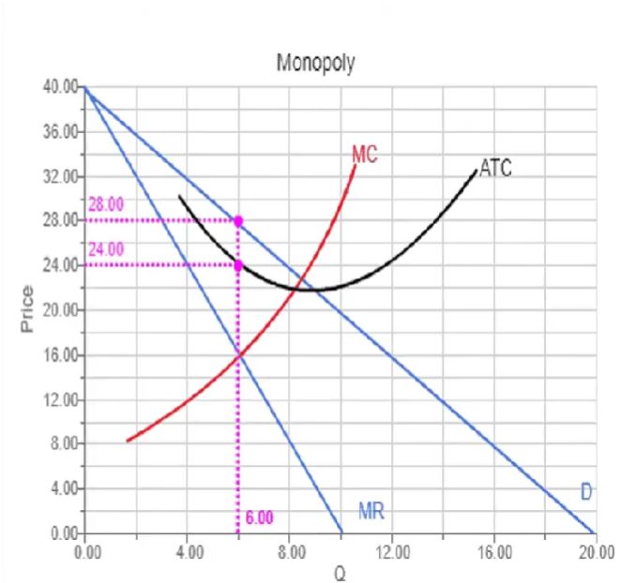

1. What is the profit maximizing output, q*? (answer:6)
2. What is the profit maximizing price? (answer: 28)
3. Calculate TR. (answer:$168)
4. What is the ATC at q*? (answer: $24)
5. Calculate total cost:(answer: $144)
6. Calculate the Profit. (Answer: $24)

